Justin Dyer

J00655685

Abstract

Assessing knowledge of Chapters 4 and 6 in Instrumentation and Experimental Methods.

Instrumentation Assesment

Assessment 2 – Chapters 4&6

**Honor Pledge**

I Justin Dyer, have read the description above and acknowledge that I did not contact another human being whether digitally or face to face to receive or give help on this quiz. I acknowledge that the answers below are in my own words and reflect my understanding of the material.

*DIGITAL SIGNATURE*

*DATE*

Problem 1:

1. Assume you have 4 ADCs each with varying bits. They have 4, 8, 16 and 32 bits respectively. The input voltage is 1.28 V and the input range is 0-5V.
2. First, compute the Digital output of each Analog to digital converter
3. Convert the digital output back to voltage using the voltage range / 2^N where N is the number of bits. Do this for all 4 ADCs.
4. Compute the error between the measured voltage and the actual input voltage for all 4 ADCs
5. Plot the error as a function of N using Python.

Solution:

To begin this problem, I want to lay out my givens in an organized way. I decided to set this up in columns to better follow the steps of this process. Below is a representation of my setup:

V­­in = 1.28 V Vupper = 5 V Vlower = 0 V

N4 = 4-bit N8 = 8-bit N16 = 16-bit N32 = 32-bit

This is the setup I will use to solve the problem in an organized manner.

The relationship that an analog digital converter uses to relate an input voltage to an output digital signal can be expressed as follows:

(Eqn 1.1)

where Vin is the input voltage, Do is the digital output as a truncated integer, Vupper is the upper input voltage range, Vlower is the lower input voltage range, and N is the number of bits. Solving for the digital output one gets the following equation:

(Eqn 1.2)

Let’s apply this equation to each column of our setup:

Do,4 = 4 Do,8 = 65 Do,16 = 16777 Do,32 = 1099511628

To convert these digital outputs back to voltage we will use Eqn 1.1 as follows:

Vin,4 = 1.25 V Vin,8 = 1.27 V Vin,16 = 1.27998 V Vin,32 = 1.28 V

To find the error, we will compare our computed input voltage to the actual input voltage with the following equation:

Eqn 1.3

= 2.34375%= 0.78125%

= 0.0015625%

= 0%

One could infer from this that by increasing the number of bits, the less error and more accurate readings can be made. To show this, I wrote the following code to plot the relationship of error versus bit size:

"""

Created on Tue Apr 19 12:53:30 2022

@author: Justin

"""

##EDIT

##Instrumentation Assesment 2 Problem 1

##Import needed modules

import numpy as np

import matplotlib.pyplot as plt

##Givens

Vin = 1.28

Vup = 5

Vlow = 0

bits = np.array([4,8,16,32])

#Solution calculated by hand

error_hand = np.array([2.34375,0.78125,0.0015625,0])

#Print Givens

print('Input voltage = ', Vin)

print('Voltage range = ', Vlow,'-',Vup,'V')

#Take input voltage and bits and convert to digital

digitalout = []

for i in [4,8,16,32]:

    out = np.trunc((Vin-Vlow)/((Vup-Vlow)/(2**i)))

    digitalout.append(out)

    print('Digital Output of', i, 'bit: ', out)

#Take digital signal back to voltage

count = 0

Vreversed = []

for i in [4,8,16,32]:

    if count == 0:

        count = 0

    Vrev = (digitalout[count]*((Vup-Vlow)/2**i))+Vlow

    count = count + 1

    Vreversed.append(Vrev)

    print('Digital signal converted to voltage of',i,'bit: ', Vrev, 'V')

#Compute error

error = []

count = 0

for i in Vreversed:

    e = ((Vin-i)/Vin)*100

    error.append(e)

    print('Error of ',bits[count], 'bit: ', e,'%')

    count = count+1

#Plot

plt.plot(bits,error_hand,'r-', label= 'Hand Computed')

plt.plot(bits,error,'b-',label= 'Python Computed')

plt.xlabel('N (number of bits)')

plt.ylabel('%error from actual value')

plt.title('Error as function of bits')

plt.legend()

plt.grid()

#Show plot

plt.show()

The output of this script yields the following:

Input voltage = 1.28

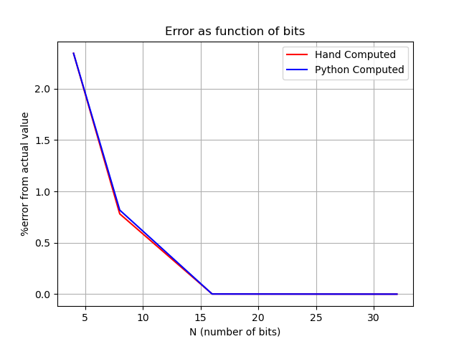Voltage range = 0 - 5 V

Digital Output of 4 bit: 4.0

Digital Output of 8 bit: 65.0

Digital Output of 16 bit: 16777.0

Digital Output of 32 bit: 1099511627.0

Digital signal converted to voltage of 4 bit: 1.25 V

Digital signal converted to voltage of 8 bit: 1.26953125 V

Digital signal converted to voltage of 16 bit: 1.2799835205078125 V

Digital signal converted to voltage of 32 bit: 1.279999999096617 V

Error of 4 bit: 2.343750000000002 %

Error of 8 bit: 0.8178710937500021 %

Error of 16 bit: 0.0012874603271505192 %

Error of 32 bit: 7.05767909392474e-08

[Click here to redirect to GitHub to use code.](https://github.com/TheJus10Dyer/Justin/blob/main/School/INSTLab_proj/INSTtest2problem1.py)